**Overloading and Overriding Interview Questions**

1. **What is method overloading?**
2. **Can we have two methods in a class with the same name?**
3. **Why is method overloading not possible by changing the return type in java?**
4. **What is method overriding?**
5. **What is the difference between method overriding and method overloading?**
6. **Can we overload main() method?**

 Yes, **main method can** be **overloaded**. **Overloaded main method** has to be called from inside the "public **static** void**main**(String args[])" as this is the entry point when the class is launched by the JVM.

1. **Can we override the overloaded method?**
2. **What are the differences between method Overloading and Overriding.**
3. **Can we override static methods of a class?**

## Properties of method overloading in Java 1) *Overloaded methods* are bonded using [static binding in Java](http://javarevisited.blogspot.sg/2012/03/what-is-static-and-dynamic-binding-in.html). Which occurs during compile time i.e. when you compile Java program. During the compilation process, compiler bind method calls to the actual method. 2) Overloaded methods are fast because they are bonded during compile time and no check or binding is required during runtime. 3) Most important rule of method overloading in Java is that two overloaded methods must have a different signature.Here is an example of *What does method signature means in Java*: 1) A number of argument to a method is part of method signature. 2) Type of argument to a method is also part of method signature 3) Order of argument also forms part of method signature provided they are of different type. 4) The return type of method is not part of the method signature in Java. Method Overloading Example in Java

Here is a list of method and there corresponding overloaded method with reason that How they are overloaded :  
  
Original method :

 public void  show(String message){

      System.out.println(message);

}

Overloaded method : number of argument is different

 public void  show(String message, boolean show){

      System.out.println(message);

}

Overloaded method : type of argument is different

 public void  show(Integer message){

      System.out.println(message);

}  
Not a Overloaded method : only return type is different

 public boolean show(String message){

      System.out.println(message);

      return false;

}

In summary **method, overloading means multiple methods with the same name** but with a different signature. remember return type is not part of method signature. method overloading is also completely different to method overriding which is a similar concept and we will see in next article. That's all on What is method overloading in Java, let me know if you have any question related to How to overload a method in Java.

**1) What is method overloading in Java?**  
If you have two method which does same thing its better they have same name, but two method cannot have same name until you overload them. So overloading is a process of declaring two methods with same name but different method signature e.g. System.out which is object of PrintStream class has several println() method to print different data types e.g. byte, short, int, char, float and double. All of them are called overloaded method. Overloaded method calls are resolved during compile time in Java and they must have different method signatures. See [here](http://java67.blogspot.sg/2012/08/what-is-method-overloading-in-java-example.html) to learn more about method overloading in Java.

Best Example in java for Overloading;

### Commonly used methods of PrintStream class

|  |
| --- |
| There are many methods in PrintStream class. Let's see commonly used methods of PrintStream class:   * **public void print(boolean b):** it prints the specified boolean value. * **public void print(char c):** it prints the specified char value. * **public void print(char[] c):** it prints the specified character array values. * **public void print(int i):** it prints the specified int value. * **public void print(long l):** it prints the specified long value. * **public void print(float f):** it prints the specified float value. * **public void print(double d):** it prints the specified double value. * **public void print(String s):** it prints the specified string value. * **public void print(Object obj):** it prints the specified object value. * **public void println(boolean b):** it prints the specified boolean value and terminates the line. * **public void println(char c):** it prints the specified char value and terminates the line. * **public void println(char[] c):** it prints the specified character array values and terminates the line. * **public void println(int i):** it prints the specified int value and terminates the line. * **public void println(long l):** it prints the specified long value and terminates the line. * **public void println(float f):** it prints the specified float value and terminates the line. * **public void println(double d):** it prints the specified double value and terminates the line. * **public void println(String s):** it prints the specified string value and terminates the line./li> * **public void println(Object obj):** it prints the specified object value and terminates the line. * **public void println():** it terminates the line only. * **public void printf(Object format, Object... args):** it writes the formatted string to the current stream. * **public void printf(Locale l, Object format, Object... args):** it writes the formatted string to the current stream. * **public void format(Object format, Object... args):** it writes the formatted string to the current stream using specified format. * **public void format(Locale l, Object format, Object... args):** it writes the formatted string to the current stream using specified format. |

## ======================================================================= 2) What is method overriding in Java? Method overriding is another way to define method with same name but different code but it must be in sub class. Overriding is based upon run-time Polymorphism as method calls are resolved at run-time depending upon actual object.  For example if a variable of type Parent holds an object of Child class then method invoked will be from child class and not parent class, provides its overridden. In order to override a method, you must follow rules of method overriding which means declaring method with same signature in sub class. See [here](http://java67.blogspot.sg/2012/08/what-is-method-overriding-in-java-example-tutorial.html) to learn more about method overriding in Java. Method Overriding Rules in Java

Overriding is completely different than overloading and so it's rules are also different. For terminology, original method is known as overridden method and new method is known as overriding method. Following rules must be followed to correctly override a method in Java :  
  
1) A method can only be overridden in sub class, not in same class. If you try to create two methods with same signature in one class compiler will complain about it saying *"duplicate method in type Class"*, as shown in following screenshot :

[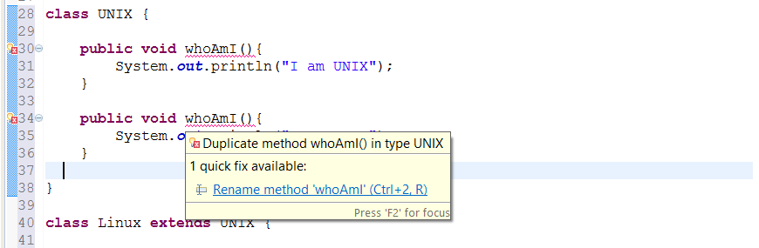](http://3.bp.blogspot.com/-t47anhssz58/VDahGgnVwnI/AAAAAAAACAg/5FMVdLJLmdA/s1600/Duplicate+Methods+in+Java+Class.png)

//asked in citi interview  
2) Overriding method cannot throw [checked Exception](http://javarevisited.blogspot.sg/2011/12/checked-vs-unchecked-exception-in-java.html) which is higher in hierarchy, than checked Exception thrown by overridden method. For example if overridden method throws IOException or [ClassNotfoundException](http://javarevisited.blogspot.sg/2011/08/classnotfoundexception-in-java-example.html), which are checked Exception, than overriding method can not throw java.lang.Exception because it comes higher in type hierarchy (it's super class of IOException and ClassNotFoundExcepiton). If you do so, compiler will catch you as seen in following image :

[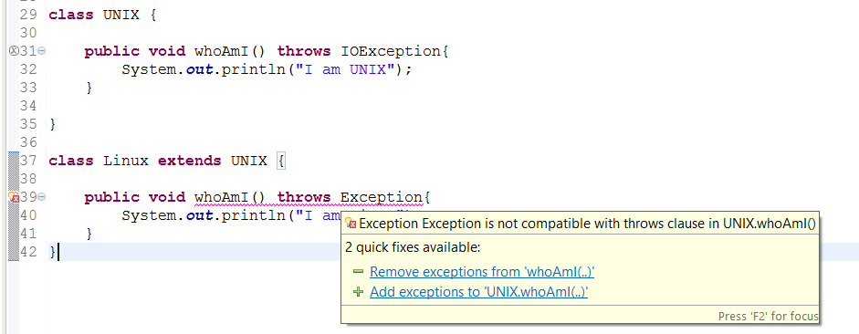](http://2.bp.blogspot.com/-T6aIcnQ2Azg/VDah4fe5XlI/AAAAAAAACAo/VGheJkOc0r4/s1600/Overriding+Method+cannot+throw+higher+checked+Exception+in+Java.png)

//work fine if you do like below

**public** **class** Unix {

//this is overridden Method

**public** **void** whoAmI() **throws** Exception {

System.***out***.println("I am UNIX");

}

}

**public** **class** Linux **extends** Unix {

**public** **void** whoAmI() **throws** IOException{

System.***out***.println("I am UNIX");

}

}

3) Overriding method can not reduce access of overridden method. It means if overridden method is defined as public than overriding method can not be protected or package private. Similarly if original method is protected then overriding method cannot be package-private. You can see what happens if you violate this rule in Java, as seen in this screenshot it will throw compile time error saying "You cannot reduce visibility of inherited method of a class".

[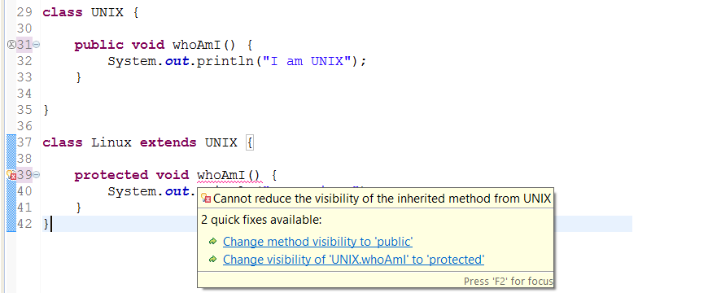](http://2.bp.blogspot.com/-XFeTyJzJkDs/VDajQMf3U1I/AAAAAAAACA0/JvPw6S2ewGM/s1600/Cannot+reduce+visibility+of+inherited+method+while+overriding+in+Java.png)

4) Overriding method can increase access of overridden method. This is opposite of earlier rule, according to this if overridden method is declared as protected than overriding method can be protected or public. Here is an example to see that it's allowed in Java :

[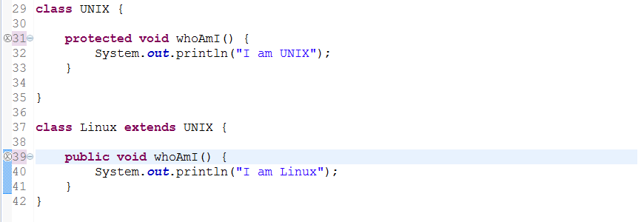](http://3.bp.blogspot.com/-iBrh0VYzgC0/VDakAoMn-QI/AAAAAAAACA8/Yn-uSMFybLc/s1600/You+can+increase+visibility+of+overridden+method+in+Java.png)

5)[**private**](http://java67.blogspot.sg/2012/08/can-we-override-private-method-in-java.html)**,**[**static**](http://java67.blogspot.sg/2012/08/can-we-override-static-method-in-java.html) and [**final method**](http://javarevisited.blogspot.sg/2011/12/final-variable-method-class-java.html) can not be overridden in Java. See other articles in this blog to learn why you cannot override private, static or final method in Java. By the way, you can hide private and static method but trying to override final method will result in compile time error "Cannot override the final method from a class" as shown in below screenshot :

[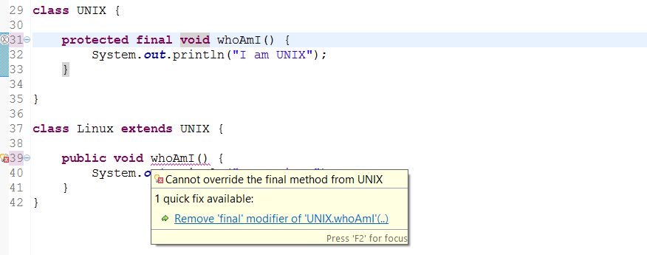](http://1.bp.blogspot.com/-XgyBk3dQLhg/VDakx18bwiI/AAAAAAAACBE/RIw9w9P31hw/s1600/Cannot+override+the+final+method+from+a+Class+in+Java.png)

6) Return type of overriding method must be same as overridden method. Trying to change return type of method in child class will throw compile time error "return type is incompatible with parent class method" as shown in following screenshot.

[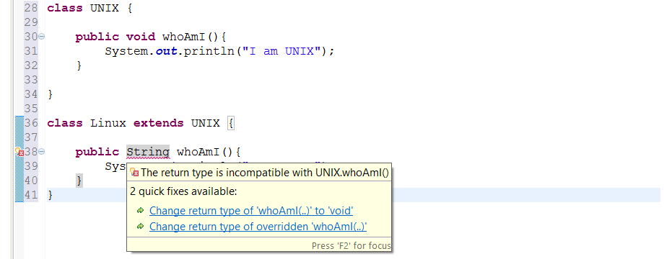](http://4.bp.blogspot.com/-lzbzFVMIxHk/VDafe9HmJQI/AAAAAAAACAU/81dKojfi_X0/s1600/Method+Overriding+Cannot+be+done+by+just+changing+return+type.png)

Read more: <http://www.java67.com/2012/09/what-is-rules-of-overloading-and-overriding-in-java.html#ixzz4u24NZnEO>**Method Overriding Example in Java**

Now we know *what is method overriding in Java* and *rules of method overriding*, It's time to see an example of how to override method in Java. In this example we have used [Runnable interface](http://javarevisited.blogspot.sg/2011/02/how-to-implement-thread-in-java.html) which has an abstract run() method. We have two class Task and PeriodicTask which implements Runnable interface and override run method. For the purpose of demonstrating how method overriding works in Java we are calling run() method in same thread, which you should not, see [difference between run and start method](http://javarevisited.blogspot.sg/2012/03/difference-between-start-and-run-method.html) to know why. Because run() is overridden in two separate class, call to run() method will be resolved during runtime depending upon type of Object.

/**  
 *  
 * Java program to demonstrate **how to override method in Java**.  
 * Overridden method are resolved during runtime based upon type of object  
 *  
 * @author Javin  
 */  
**public** **class** CollectionTest {  
    
    **public** **static** **void** main(**String** args[]) {  
    
      **Runnable** task = **new** Task();  
      task.run(); *//call overridden method in Task*  
      
      task = **new** PeriodicTask();  
      task.run(); *//calls overridden method in PeriodicTas*  
  
    }  
    
    
}  
  
**class** Task **implements** **Runnable**{  
  
    @**Override**  
    **public** **void** run() {  
        **System**.out.println("Run method overridden in Task class");  
    }  
    
}  
  
**class** PeriodicTask **extends** Task{  
    
    @**Override**  
    **public** **void** run() {  
        **System**.err.println("overridden method run() in PeriodicTask class");  
    }  
}  
  
**Output:**  
Run method overridden in Task **class**  
overridden method run() in PeriodicTask **class**

That's all on **What is method overriding in Java**, *Rules of method overriding in Java* and an example of How to override method in Java. In summary remember to override all abstract method while extending form abstract class or implementing interface. Overridden method are also slower as compared to static and final methods because of dynamic binding but it provides you flexibility, many [popular Object oriented design principles](http://javarevisited.blogspot.sg/2012/03/10-object-oriented-design-principles.html) are based upon method overriding in Java.

## Method Overriding

Using method overriding, child class can provide its own implementation of the method which is already present in the parent class or declared in parent interface.

In other words, when method in the sub class has the same name, same parameters and same return type (or co-variant return type) as parent class or interface, then we can say that child class method has overridden the parent class method.

**For Example,**

Lets understand this using simple example.

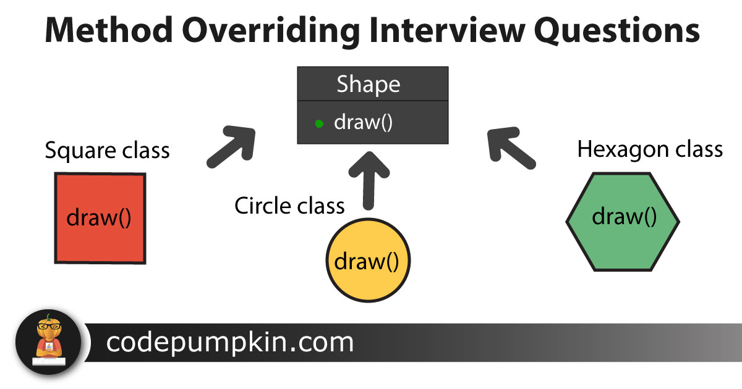

We have two classes : parent class Shape and child class Circle which extends Shape class.

Both the class has common method draw(). Circle class has provided its own implementation of draw() method. In other words, it has overridden draw() method of Shape class.

Along with draw() method, Shape class also contains fill() method which has not been overridden by Circle class. But this method will be inherited to Circle class with default implementation.

Purpose of method overriding is very clear here. Circle class wants to provide its own implementation of draw() method so that when it calls this method, it will print '**Circle**' instead of '**Shape**'.

|  |  |
| --- | --- |
|  | public class PumpkinDemo {        public static void main(String[] args) {          Shape s = new Circle();            s.draw();          s.fill(); //this method is not override by sub class      }  }    Class Shape{      public void draw()      {          System.out.println("Shape");      }        public void fill()      {          System.out.println("Shape Filled with color");      }    }    class Circle extends Shape{      public void draw()      {          System.out.println("Circle");      }  }    class Square extends Shape{      public void draw()      {          System.out.println("Square");      }  }    class Hexagon extends Shape{      public void draw()      {          System.out.println("Hexagon");      }  } |

**output**

|  |  |
| --- | --- |
| 1  2 | Circle  Shape Filled with color |

**Example 1: If base class doesn’t throw any exception but child class throws an unchecked exception.**  
In this example class Room is overriding the method color(). The overridden method is not throwing any exception however the overriding method is throwing an unchecked exception (NullPointerException). Upon compilation code ran successfully.

class Building {

void color()

{

System.out.println("Blue");

}

}

class Room extends Building{

//It throws an unchecked exception

void color() throws NullPointerException

{

System.out.println("White");

}

public static void main(String args[]){

Building obj = new Room();

obj.color();

}

}

Output:

White

**Example 2: If base class doesn’t throw any exception but child class throws an checked exception**

import java.io.*;

class Building {

void color()

{

System.out.println("Blue");

}

}

class Room extends Building{

void color() throws IOException

{

System.out.println("White");

}

public static void main(String args[]){

Building obj = new Room();

try{

obj.color();

}catch(Exception e){

System.out.println(e);

}

}

}

Output:

Exception in thread "main" java.lang.Error: Unresolved compilation problem:

Exception IOException is not compatible with throws clause in Building.color()

The above code is having a compilation error: Because the overriding method (child class method) cannot throw a checked exception if the overridden method(method of base class) is not throwing an exception.

**Example 3: When base class and child class both throws a checked exception**

import java.io.*;

class Building {

void color() throws IOException

{

System.out.println("Blue");

}

}

class Room extends Building{

void color() throws IOException

{

System.out.println("White");

}

public static void main(String args[]){

Building obj = new Room();

try{

obj.color();

}catch(Exception e){

System.out.println(e);

}

}

}

Output:

White

The code ran fine because color() method of child class is **NOT** throwing a checked exception with scope broader than the exception declared by color() method of base class.

**Example 4: When child class method is throwing border checked exception compared to the same method of base class**

package beginnersbook.com;

import java.io.*;

class Building {

void color() throws IOException

{

System.out.println("Blue");

}

}

class Room extends Building{

void color() throws Exception

{

System.out.println("White");

}

public static void main(String args[]){

Building obj = new Room();

try{

obj.color();

}catch(Exception e){

System.out.println(e);

}

}

}

Output:  
Compilation error because the color() method of child class is throwing Exception which has a broader scope than the exception thrown by method color() of parent class.

## Why Is It Known As Runtime Polymorphism?

In above example, we have created reference of type Shape, but object of type Circle. When we call method draw(), jvm decides method of which class needs to be called at runtime.

In short, if we create a object of child class and if child class has overridden the method, then child class method will be called e.g. draw(). If method has not been overridden in the child class, then parent class method will be called e.g. fill().

You can also refer our article on [method overloading](http://codepumpkin.com/java-method-overloading-interview-questions) to know more about Compile-Time Polymorphism or static binding.

## Programming Interview Questions

We have divided the questions into six categories so that it would be easier for you to understand the concepts.

1. [Access Modifiers](http://codepumpkin.com/method-overriding-interview-questions/#AccessModifiers)
2. [static methods](http://codepumpkin.com/method-overriding-interview-questions/#static)
3. [Member Variables](http://codepumpkin.com/method-overriding-interview-questions/#memberVariables)
4. [Exception Handling](http://codepumpkin.com/method-overriding-interview-questions/#ExceptionHandling)
5. [Return types](http://codepumpkin.com/method-overriding-interview-questions/#ReturnTypes)
6. [Method Parameters](http://codepumpkin.com/method-overriding-interview-questions/#MethodParameters)

We have listed down all such questions and their answers with explanation. But we suggest you guys to first try solving and guessing the answer of each question and then read its answer.

## Access Modifiers

**Question 1)**What would be the output of below code?

|  |  |
| --- | --- |
|  | public class PumpkinDemo {        public static void main(String[] args) {          Shape s = new Circle();          s.draw();      }  }    class Shape{      protected void draw()      {          System.out.println("Shape");      }  }    class Circle extends Shape{      public void draw()      {          System.out.println("Circle");      }  } |

Here method in parent class has protected scope, but in child class it is public. Will method overriding work here? Will it print **Shape**or **Circle**?

**Answer:**Method overriding has nothing to do with [access modifier scopes](http://codepumpkin.com/access-modifiers-in-java). It will print **Circle** in above code.

**Question 2)**As a follow up question, interviewer may ask you : What will happen if I change scope of draw() method from protected to private in Shape class?

**Answer :**It will give you a compile time error in main() method where you are calling s.draw() as we can not call the private method from outside the class.

**Question 3)**What would be the output of below code?

|  |  |
| --- | --- |
|  | public class PumpkinDemo {        public static void main(String[] args) {          Shape s = new Circle();          s.draw();      }  }    class Shape{      public void draw()      {          System.out.println("Shape");      }  }    class Circle extends Shape{      private void draw()      {          System.out.println("Circle");      }  } |

**Answer:**

Above code will give you compile time error as we cannot reduce the visibility or scope of the inherited method from parent class i.e. public void draw() to private void draw().

## Static Methods

**Question 4)**This question is not related to inheritance or method overriding, but it is one of our favorite question. Many programmer gives confused look when we ask them this one. Have a look at below code and guess the output.

|  |  |
| --- | --- |
|  | public class PumpkinDemo {        public static void main(String[] args) {          Shape s = null;          s.draw();      }  }    class Shape{      public static void draw()      {          System.out.println("Shape");      }  } |

Will above code give NullPointerException? Or it will print **Shape** as output?

**Answer :**It won't give NullPointerException as draw() is a static method and compiler will replace reference variable with class name i.e. Shape.draw()

**Question 5)**What would be the output of below code?

|  |  |
| --- | --- |
|  | public class PumpkinDemo {        public static void main(String[] args) {          Shape s = new Circle();          s.draw();      }  }    class Shape{      public static void draw()      {          System.out.println("Shape");      }  }    class Circle extends Shape{      public static void draw()      {          System.out.println("Circle");      }  } |

**Answer:**

It will print **Shape** as output. Method overriding happens only with instance methods. Static methods are attached to class and compiler converts reference variable to class name i.g. Shape.draw()

**//Asked in interview**

**Question 6)**What will happen if we will remove static keyword from the draw() method of Circle class. Shape class still contains the public static void draw() method.

**Answer:**It will give compile-time time error saying 'This instance method cannot override the static method from Shape'.

## Member Variables

**Question 7)**Guess the output of below code

|  |  |
| --- | --- |
|  | public class PumpkinDemo {       public static void main(String[] args) {          Shape s = new Circle();          System.out.println(s.name);      }  }  class Shape{      String name = "Shape";  }    class Circle extends Shape{      String name = "Circle";  } |

**Output:**

|  |  |
| --- | --- |
| 1 | Shape |

**Answer :**Member variables cannot be overridden. In other words, Variables are resolved at compile-time and methods at run-time.

## Exception Handling

**Question 8)**Can overridden method throw different exception than the one being thrown in parent class method. For Example, Will below code compile successfully?

|  |  |
| --- | --- |
|  | import java.io.FileNotFoundException;  import java.io.IOException;    public class PumpkinDemo {        public static void main(String[] args) throws IOException{          Shape s = new Circle();          s.draw();      }  }    class Shape{      public void draw() throws IOException      {          System.out.println("Shape");      }  }    class Circle extends Shape{      public void draw() throws FileNotFoundException      {          System.out.println("Circle");      }  } |

**Answer:**

While overriding a method, you can compress the scope of checked exception but you cannot widen it. Also you can not throw any other checked exception which is not being thrown in parent class method.

Here, FileNotFoundException is a child class of IOException. So, above code will compile successfully and it will give **Circle**as output.

If we change FileNotFoundException to generic Exception in above code, then it will give compile time error saying 'Exception Exception is not compatible with throws clause in Shape.draw()'.

**Question 9)**Will below code compile successfully?

|  |  |
| --- | --- |
|  | public class PumpkinDemo {        public static void main(String[] args){          Shape s = new Circle();          s.draw();      }  }    class Shape{      public void draw() throws ArithmeticException      {          System.out.println("Shape");      }  }    class Circle extends Shape{      public void draw() throws RuntimeException      {          System.out.println("Circle");      }  } |

**Answer:**Yes. Overridden methods can throw any RuntimeException irrespective of its scope unlike checked exception.

## Return Type

**Question 10)**Can a return type be different in overridden method? Guess the output of below code.

|  |  |
| --- | --- |
|  | public class PumpkinDemo {       public static void main(String[] args){          Parent p = new Child();          p.testMethod();      }  }    class Parent{      public Number testMethod()      {          System.out.println("Parent");          return 0;      }  }   class Child extends Parent{      public Integer testMethod()      {          System.out.println("Child");          return 0;      }  } |

**Answer:**Above code will compile successfully and prints **Child**as output. So is different return type allowed in method overriding?

Well Number is a parent class of [Integer Wrapper class](http://codepumpkin.com/interview-questions-wrapper-classes), and that is why above code compiled successfully. They are called covariant return types. You can check Wrapper classes Hierarchy in below image.

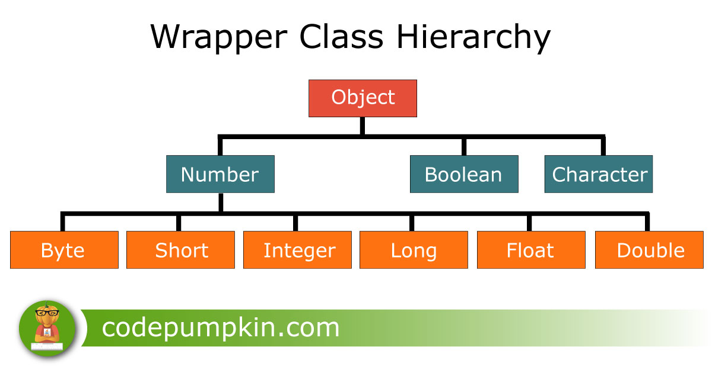

The **covariant return types** are newly introduced since Java 5.0, and used during **method overriding**. **Covariant return type** allows us to change the **return type** of the **overriding method** in the subclass; however this **return type** in subclass **method** must be a subtype of super class **method return type**.

Below two combinations will give you compile time errors:

1) Parent class method return type : Integer,   
     Child class method return type : Number or Long

2) Parent class method return type : String,   
     Child class method return type : Number or Long

## Method Parameters

**Question 11)**Here are the last two questions of this article. Guess the output of below code:

//its not overriding

|  |  |
| --- | --- |
|  | public class PumpkinDemo {       public static void main(String[] args){          Parent p = new Child();          p.testMethod(0);      }  }    class Parent{      public void testMethod(Number n)      {          System.out.println("Parent");      }  }    class Child extends Parent{      public void testMethod(Integer n)      {          System.out.println("Child");      }  } |

Confused? Does java allows covariant method parameters? Is this method overriding?

**Answer:**

Well, compiler will consider both of above methods as different methods and it is not method overriding. Above program will give priority to Parent class testMethod() and prints **Parent** as output.

**Question 12)**What will be the output if we change main() method as below

|  |  |
| --- | --- |
|  | public static void main(String[] args){      Child p = new Child();      p.testMethod(0);  } |

**Output:**

|  |  |
| --- | --- |
| 1 | Child |

Interesting, isn't it?

========================

Can we override static method in Java - Method Hiding  
  
No, you cannot override static method in Java because [method overriding](http://java67.blogspot.sg/2012/08/what-is-method-overriding-in-java-example-tutorial.html) is based upon dynamic binding at runtime and static methods are bonded using [static binding](http://javarevisited.blogspot.sg/2012/03/what-is-static-and-dynamic-binding-in.html) at compile time. Though you can declare a method with same name and method signature in sub class which does look like you can override static method in Java but in reality that is method hiding. Java won't resolve method call at runtime and depending upon type of Objectwhich is used to call [static method](http://javarevisited.blogspot.sg/2011/11/static-keyword-method-variable-java.html), corresponding method will be called. It means if you use Parent class's type to call static method, original static will be called from patent class, on ther other hand if you use Child class's type to call static method, method from child class will be called. In short you can not override static method in Java. If you use Java IDE like [Eclipse](http://javarevisited.blogspot.sg/2011/02/how-to-setup-remote-debugging-in.html) or Netbeans, they will show warning that static method should be called using class name and not by using object becaues *static method can not be overridden in Java*.

**3) What is method hiding in Java?**  
static method cannot be overriding in Java because their method calls are resolved at compile time but it didn't prevent you from declaring method with same name in sub class. In this case we say that method in sub class has hided static method from parent class. If you have a case where variable of Parent class is pointing to object of Child class then also static method from Parent class is called because overloading is resolved at compile time. See [here](http://java67.blogspot.sg/2012/08/can-we-override-static-method-in-java.html) to learn more about method hiding in Java.

Overriding Static method in Java - Example

In last section we saw theory that we can not override static methods in Java, static method can only be hidden in sub class. Let's see an example to test that theory which says [you can not override static method in Java](http://javarevisited.blogspot.sg/2011/11/static-keyword-method-variable-java.html)

/**  
 *  
 * Java program which demonstrate that we **can not override static method in Java**.  
 * Had Static method can be overridden, with Super class type and sub class object  
 * static method from sub class would be called in our example, which is not the case.  
 * @author  
 */  
**public** **class** CanWeOverrideStaticMethod {  
    
    **public** **static** **void** main(**String** args[]) {  
        
        Screen scrn = **new** ColorScreen();  
        
        *//if we can  override static , this should call method from Child class*  
        scrn.show(); *//IDE will show warning, static method should be called from classname*  
        
    }    
    
}  
  
**class** Screen{  
    
    */*  
     * public static method which can not be overridden in Java  
     */*  
    **public** **static** **void** show(){  
        **System**.out.printf("Static method from parent class");  
    }  
}  
  
**class** ColorScreen **extends** Screen{  
    */*  
     * static method of same name and method signature as existed in super  
     * class, this is not method overriding instead this is called  
     * method hiding in Java  
     */*  
    **public** **static** **void** show(){  
        **System**.err.println("Overridden static method in Child Class in Java");  
    }  
}  
  
**Output:**  
Static method from parent **class**